**MYSTERIOUS ISLAND TOURS &SAFARIS.**

**TOURS EXPERIENCE**

Mysterious islands tours &safaris Tour guides have over 20 years of experience welcoming and guiding visitors through the islands of Zanzibar .Mysterious islands TOURS &Safaris boast to be among the few agents providing services in swahili, English French,German,italian, and Spanish languages.



**TRANSFERS**



We organize transfers from and to Airports also seaports pick-ups. we have different motor vehicles to choose from according to your comfort, our experienced drivers and multilingual guides are knowledgeable,friendly and professional to provide our guests to the most memorable experience from their holiday.

**MISSION**

To become zanzibar's leading tour operator by means of providing excellent services, by building strong realations to our clients and supporting growth and development in the tourism and overall economy of Zanzibar and Tanzania.

**VISSION**

**To** provide efficient and quality services to our clients who chose to work with us during their time in zanzibar and Tanzania in general on time and on budget

**OUR DESTINATIONS**

* **UNGUJA ISLAND**

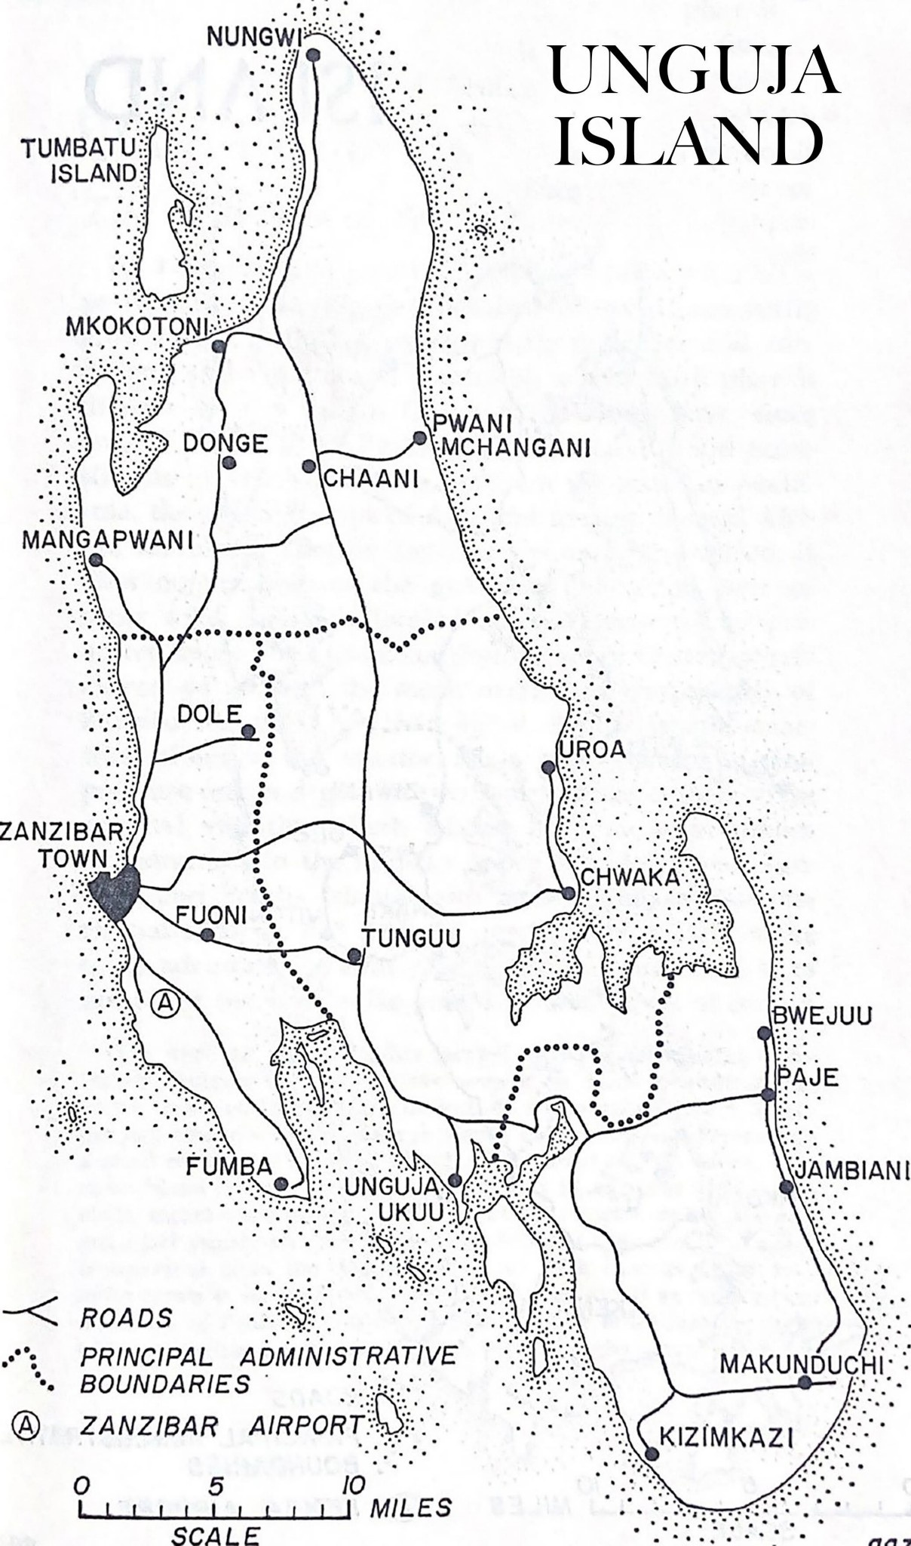

* **PEMBA ISLAND**

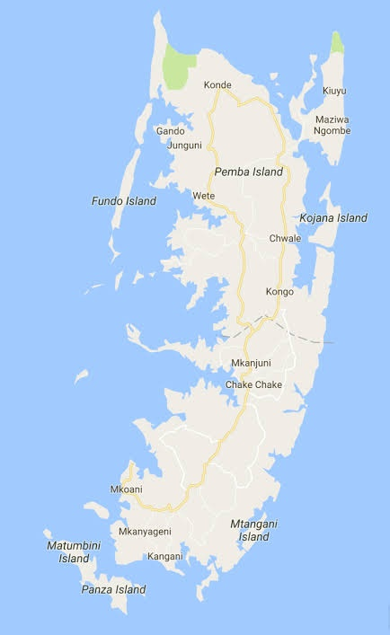

* **TANZANIA UNKNOWN TREASURE.**

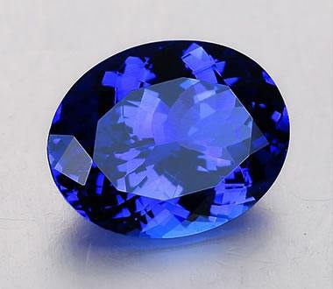

**ADVENTURE TOURS**

**Jozani Forest Tour**

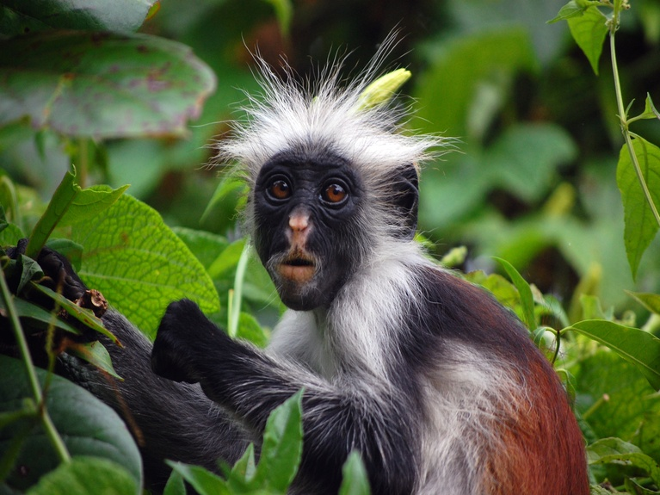

This is about 25 minutes drive from Paje and is part of Chwaka by national park. It is most famous for its red colobus monkey which are very rare and are only found here. There is also a turtle sanctuary. The park has a wide variety of nature real habitat including forest and mangrove swamp. Guided tours are available

including guided walks through the forest and the mangrove swamp. A visit takes about half a day and there is nice a local restaurant close to the main entrance area of the park.

**Dolphin Tours**

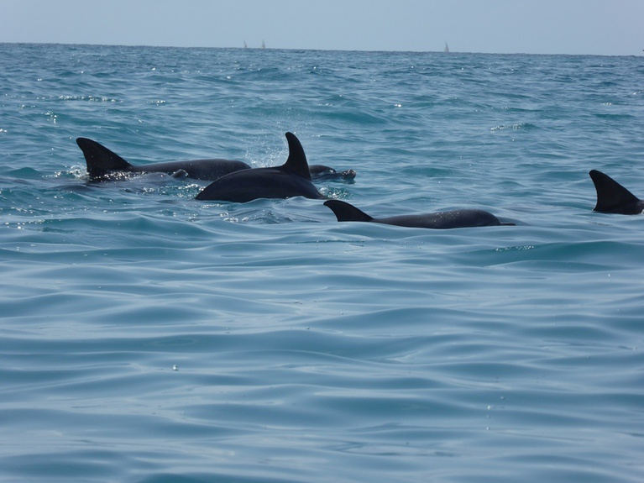

Most popular dolphin spotting location in Zanzibar is in Kizimkazi village located on the Southern coast of Zanzibar Island where you can see both bottle-nose and humpback dolphins.

The shallow coastal waters around

Kizimkazi are a favorite hangout for dolphins that come here for the reliable food supply, to nurse their calves, rest and socialize.

Several bottle-nose dolphins stay at Kizimkazi all year-round. There are also rather shyer humpback dolphins that put in an appearance here, although their schedule is a little more erratic.

Dolphin tour is best to be done very early in the morning, because in the afternoon as the sun rises sea water tends to become warm, therefore dolphins dive deep down the sea bottom to escape heat, for the guests who stay in Stone town hotel, we pick them up from their hotels at 06:00am and 05:00am from beach hotels.

You can do the trip later in the afternoon

but the probability to see dolphins is very small, not only that but at this time there might be many boats at the dolphin sites this scare the dolphins which is not good for their sustainability.

Although dolphin-spotting is a popular activity, sightings aren’t guaranteed 100%, and actually managing to swim with dolphins is a rare occurrence, like with other wild animals spotting dolphins require time and patience as they are not confined in a cage or a zoo, they are in their natural environment. Dolphin trips last two to three hours.

Kizimkazi is also the site of a 12th century mosque, the earliest evidence of Islam in East Africa, and is thus worth a visit for both cultural and historical reasons. We provide Lunch on full day trips Only at the

beach restaurant. We advice clients to wear their swimming costume. We also advise to wear waterproof sandals for boarding the dhows and to bring sunscreen, towel and spare T – shirt for snorkeling.

The dolphin trip can also be combined with Jozani Forest, as the forest is on the way to Kizimkazi; we pass through the forest on the way back from dolphin tour.

**Sunset Dhow Tour**

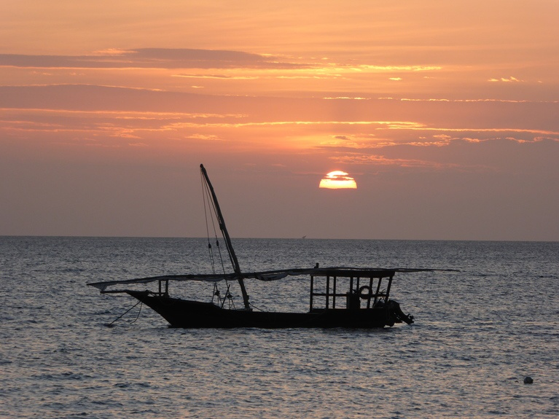

After you step on-board the vessel, the skilled crew on board direct the Dhow about 1km away from shore by means of an engine, once out in the sea the engine is shut off and during a tense moment the skillful crew put up the sail, once the sail is in favor of the wind, the guest can sit back, relax and enjoy the peacefulness of the ocean as you hear the ripple of water on the sides of the Dhow as it glides swiftly thorough the clear turquoise water.

Our sunset cruises leave Stone Town in the late afternoon to cruise along the coast, slicing through the clear turquoise water.

The sound of the bustle of busy people in Stone Town grow faint in the distance until they seem there,only in memory,as the Dhow sail you will be served

It’s beautiful orange colors.

Your breath will be taken away by the wonder of the fiery golden -sun setting beyond the horizon as it makes the sky a magical canvas of shades of pink,purple,blues and orange. As you head back for stone town the wind gently blows into the Latin sail which is truly mesmerizing.

On board our dhow we have a personal Gide who will accompany you on your course and give you a tour of Stone Town from the water as well as be able to answer any questions that you may ask him. You will come back to the shore at 18:30hrs to take your tax back to hotel

**EXCURSION**

**Stone Town Tour**

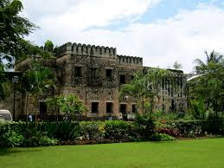

Zanzibar town (stone town) is world heritage site and has a lot of interesting buildings and a lot of winding alleyways and streets. **Walk with us along the narrowest streets in the world during this half day tour.** Within three well-invested hours you will gain a good understanding of the fascinating history of Zanzibar’s capital city and its significant areas, buildings and historical sites. You will soon notice how Zanzibar’s cosmopolitan

roots (Arabs, Indians, Yemenis, Persians, Portuguese, British, Chinese and others) blend with African traditions to shape its unique culture.

**This tour is very flexible and can be adapted to suit your interests and time frame**

**Spice Tour**

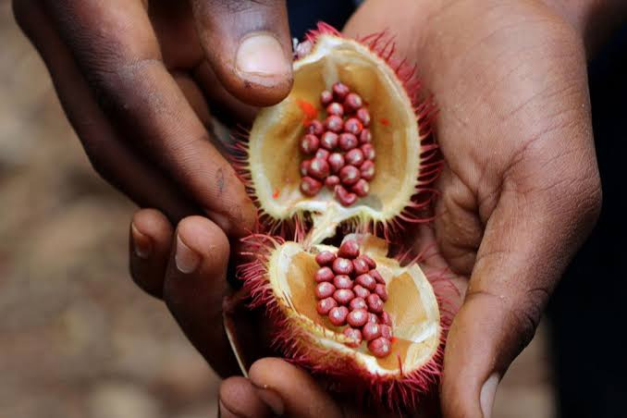

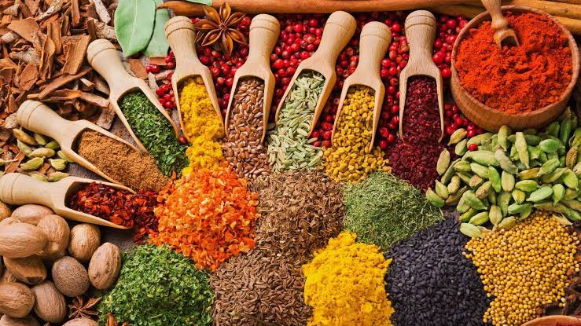

It is about one hour safe drive to the spice farm, the name of Zanzibar is called Zanzibar spice island for this reason, Zanzibar have traditionally been famous for the spice and spice plantations.

A spice tour is a wonderful way of exploring the countryside around Stone Town and Zanzibar’s rural communities. Indeed no trip to Zanzibar can be considered complete without a visit to one of our carefully selected spice farms. For centuries Zanzibar's spices, medicinal plants and tropical fruits attracted traders

across the Indian Ocean. This 3-4 hour tour will seduce your senses with a mixture of various smells, tastes and textures. Among the manydifferent plants, you will encounter are the henna bush, ylang-ylang, the lipstick tree, iodine plant, cocoa, cassava, dasheen cocoyam and – yes, Zanzibar coffee! Explore the island’s abundance of mouthwatering tropical fruits like jackfruit, pineapples, bananas, green coconut (madafu), durian, love apple (matufaa), rambutan (shoki-shoki), soursop (mabungo) and starfruit (carambola). We round off the leisurely farm walk with a home-cooked lunch in private rural ambience. The lunch consists of a wide range of typical Swahili meals prepared to perfection by a local farmer and his wife.

**Safari Blue Tour**

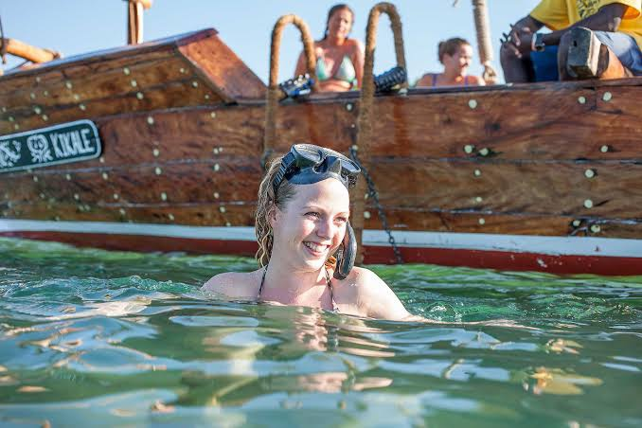

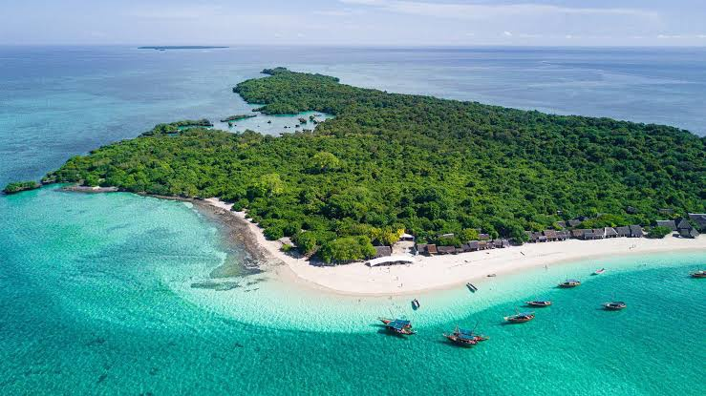

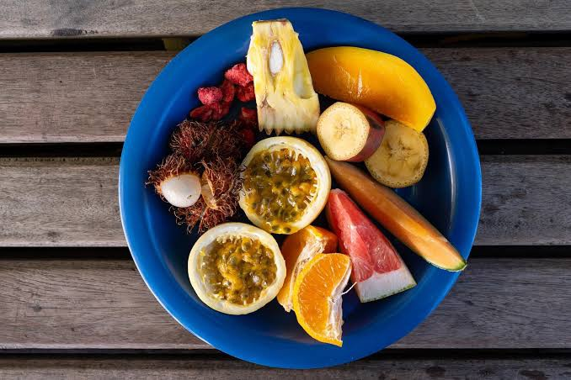

​Discover the best of Zanzibar! The Menai Bay Conservation Area, to the south of Zanzibar, is an area of outstanding natural beauty just waiting for you to discover…

Safari Blue starts from the village of Fumba a 20-minute drive from Stone Town. Fumba is the most convenient location for exploring the wildlife, isolated

sandbanks and rugged island scenery of the Menai Bay Conservation Area.

Our aim is to provide our customers with a truly memorable experience using the best Zanzibar has to offer, while making a positive difference to Zanzibar and it’s people.

This trip starts from the village of Fumba in South West Zanzibar and we will take you to see the dolphins, sandbanks, islands and coral reefs of Menai Bay, a beautiful conservation area.

In the morning we set down on one of the beautiful sandbanks where one can relax, swim or snorkel. There are plenty of good quality snorkeling equipments and the experienced snorkeling guides will show you the pristine coral reef, which teems with tropical sea life. Instruction is also

available for beginners, fresh coconuts and local snacks are available through out the day.

After snorkeling we go to Kwale island where we have our “desert island” restaurant. The buffet lunch includes fish, slipper lobster, calamari, rice and sauces all served hot from the grill. The crews also prepare and present a gastronomic fruits tasting with a large selection of delicious tropical fruits, ice cold sodas, mineral water and beer, a delicious Zanzibari seafood lunch with grilled fish and slipper lobster, coffee and Amarula liqueur.

When the tide permits we explore the natural lagoon found on Kwale island. The lagoon is surrounded by a mangrove forest and we will take you swimming in the

lagoon for an unforgettable experience.

The dhows are traditional sailing boats, hand-built from African mahogany and finished to the very highest standards. They are comfortable and well equipped with outboard engine, VHF marine radios, gas inflatable life jackets, sunshade, boarding ladder, waterproof bags and first aid kit. We hold marine and public liability insurance.

Safari Blue explores the Menai Bay Conservation Area, which is home to two different species of dolphins, the Indo-pacific humpback and the bottlenose. We are lucky enough to see dolphins on 85% of our excursions.

MenaiBay has been designated as a Conservation Area since 1998 due to its outstanding natural beauty. The bay has a number of pristine sandbanks, naturally

carved by the sea, wind and waves. The sandbanks and uninhabited islands that litter the bay are perfect stepping stones to explore the area.

Join the crew for a sail on an “ngalawa”- a local canoe with outriggers which has been carved from a single mango tree.

As Safari Blue comes to an end and we return to Fumba by traditional lanteen sail, the full splendour of the African sunset reveals itself.

**SEAWEED CENTER EXPERIENCE**

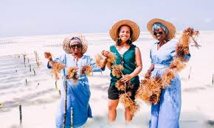

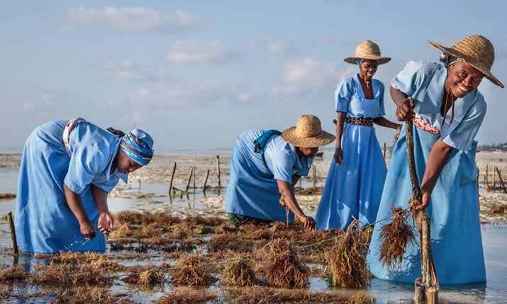

**On this tour you will visit the Seaweed**

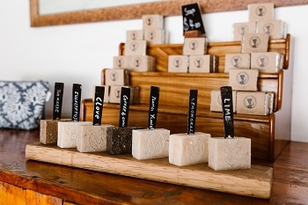

**Centre to learn about Seaweed farming, which is the second biggest industry on the island.**

Located in Paje, this social enterprise creates opportunities for female seaweed farmers to improve their healthy standard of living and engage in economic development activities that benefit the whole community. Depending on the tide

you will see how the women harvest their seaweed and understand the hard work that encompasses a seaweed famer‘s daily life. Afterwards you will gain insight in the processing centre and factory located in the village. Here you get the rare opportunity to see how the seaweed gets transformed into desirable beauty products like organic soaps and essential oils.

**Spice Farm Tour with Traditional Cooking Lesson**

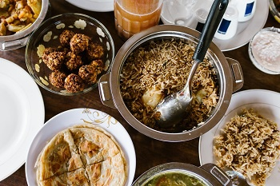

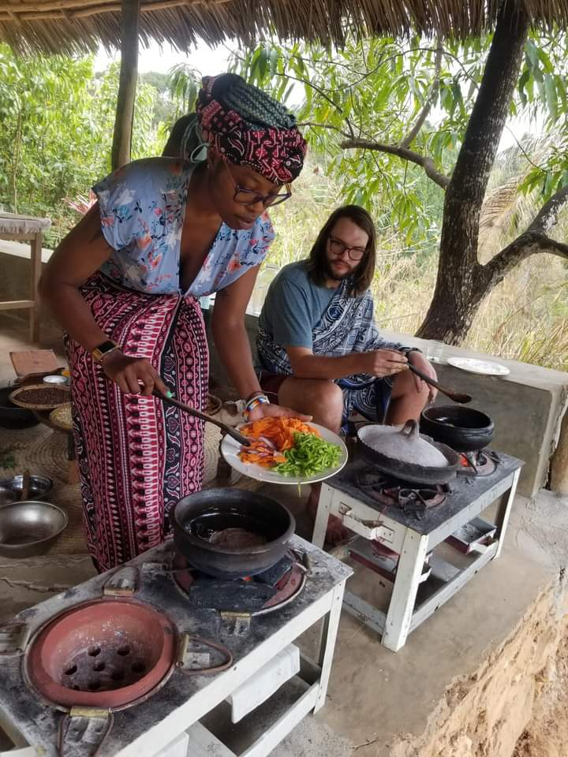

Visit a real spice farm to experience the full range of sensations offered by the finest, most freshly harvested spices. Join

in a traditional cooking lesson followed by

a harvest of cassava leaves and lunch at a spice farm. Get some new spices to try, and take some home with you.

**Cave Tour and Rock Restaurant Visit**

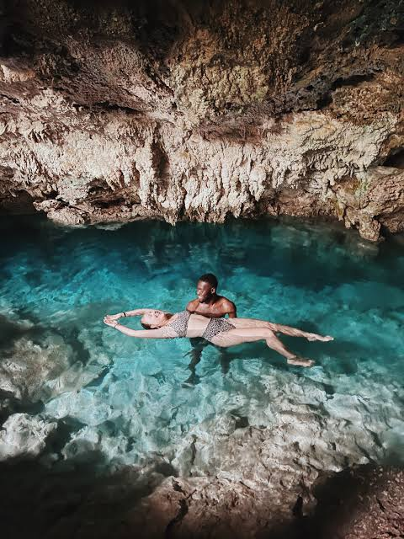

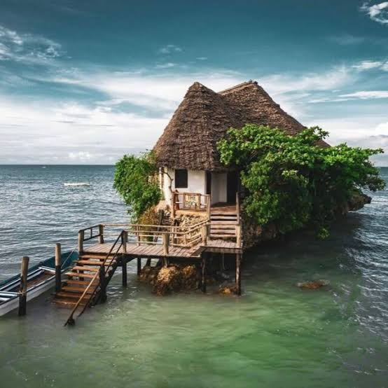

Visit a famous restaurant in Zanzibar to get toasty and take some great pictures. After that, you’ll enter a cave in the center of the jungle that offers a 50-meter-deep sinkhole.

**MNEMBA ATOLL SNORKELING**

Mnemba Atoll is a protected oceanic area

off north eastern Zanzibar near Matemwe with excellent visibility depths ranging from ten to thirty meters. It includes the small triangular island of Mnemba and a reef area comprising of two by four miles. This breathtaking marine ecosystem is famous for sightings of green turtles and dolphins that like to join you as you snorkel or dive while the seasonal migrating humpback whales announce their presence with an occasional spout of water.

You will enjoy two 45 minute long snorkelling sessions at different sites. In between your snorkel stops you will have a 45-minute break with snacks and tea. Following your last stop, the boat will return to the dive centre.

**HORSE RIDING IN NUNGWI (HALF OR**

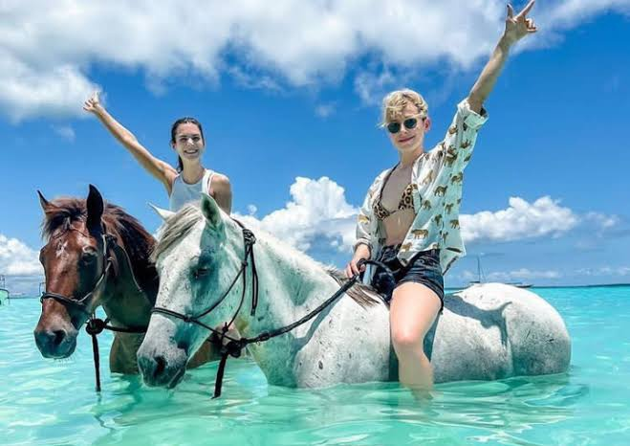

**FULL DAY TOUR)**

**If you're getting tired of lying on the beach or have already experienced the tours and excursions Zanzibar has to offer, why not ride down the beach, at sunset? Or explore coconut plantations on horseback?**

The Zanzibar Horse Club in Nungwi Beach opened in 2018. They offer a variety of

accompanied rides to suit all tastes; beach rides both in the morning and evening including sunset, swimming with horses and cultural rides in Nungwi village. All their rides are dependents on the tide but this is a great time to swim with the horses.

They offer a variety of accompanied rides to suit all tastes;

* Morning village & beach rides
* Sunset village & beach rides
* Swimming with horses
* Cultural rides trough the various village and farms of Nungwi, Kendwa, Kidoti

All their beach ride take place on the Northern Nungwi beaches, consistently

voted a top 10 beach in the world and their evening rides take in the amazing sunset. Feel free to stop by and see their stables and meet the horses. they are situated opposite the rear entrance to the Z hotel on rear village road.

10% of their profit are donated to Zaaso (a donation based horse and donkey sanctuary who also provide general animal clinic service).

If you are inexperienced or a bit nervous, it can be arranged for the horses to be led by their grooms.

There is also a riding school that caters for those who want to ride, or learn to ride, on a more regular basis. The lessons are one hour and can be arranged any day.

**ALL THE RIDES ARE SUITABLE FOR FIRST**

**TIME RIDERS AS WELL**

The horse riding might seem expensive compared with international prices, but please be aware that it is very difficult to keep horses in a good, healthy condition here in Zanzibar. Please note that we do have to mind high and low tides for most of the mentioned horse riding options and therefore often struggle with last-minute arrangements

**PRISON ISLAND JOURNEY (HALF DAY TOUR)**

About 20 minutes by boat from Forodhani area lies Changuu, also known as Prison Island. That name is misleading; although the once impressive building, erected in 1893 by Lloyd Mathews under orders of the British administrators, was originally intended as a prison, it never housed criminals. The island was, however,

reportedly used by an Arab slave trader to contain the feistier and more troublesome slaves he had brought from the African mainland. Later it became a quarantine station - but mostly it was a conveniently located leisure spot for the wealthier townsfolk.

The old prison's crumbling cells can still be seen today; they provide shelter for the resident peacocks and the giant Aldabra tortoises that Sultan Seyyid Said brought from the Seychelles in the 1820's. Some of them are almost a hundred years old.

The island is also an ideal place for sunbathing, swimming, snorkeling, or simply relaxing on the white sandy beach.

Depending on the tides, start (best) at 8 am and the latest at 3 pm (tour duration approx 2 to 3 hours). Including private guide, wooden boat with sunscreen,

entrance fees at Prison Island tortoise sanctuary, refreshments- such as fresh coconuts, drinking water & seasonal fruits

**BE WELL PREPARED**

Please take a beach towel, wear swimwear under your clothes (if wished) and apply a good amount of sun blocker with a high UV rating (reef-friendly sunscreen please) to avoid sunburn. If possible please bring suitable beach footwear for the boat transfers. It is water entry. Please wear clothing that can be pulled up above the knee, in case the water is a bit high.

**TANZANIA'S SAFARI EXPERIENCES**

**Throughout history, Tanzania has been a place of importance. It is where the**

**ancestors of humanity took their first steps, in Olduvai Gorge, one of the world’s most important historical sites. It is where ancient Swahili civilizations welcomed traders from across the Indian Ocean, opening its doors to the mix of influences that make its culture so unique today. It is where the outside world first fell in love with Africa.**

**THE NORTHERN SAFARI CIRCUIT**

 it is the most popular one among travellers, primarily because Tanzania’s most famous attractions are all contained within a manageable distance of each other. Mount Kilimanjaro, the Serengeti and Ngorongoro Crater, not to mention Lake Manyara and Tarangire, are stops in this circuit, which can be done by vehicle with only a few hours of driving from destination to destination.

**ARUSHA NATIONAL PARK**

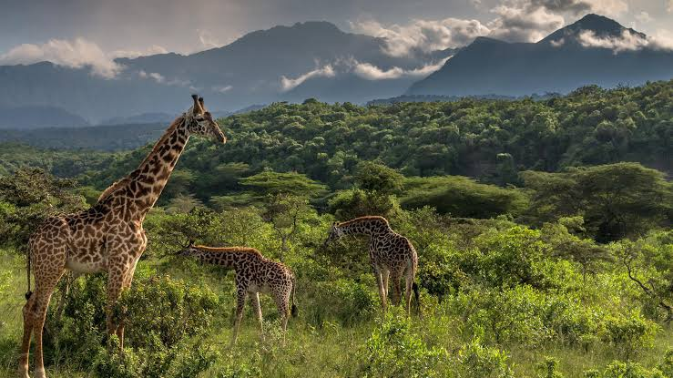

Arusha NP is only a 45-minute drive away from the town of Arusha, the starting point of any safari in northern Tanzania.

There are several ways to get to Arusha. The easiest is to get a direct flight to Kilimanjaro International Airport (JRO), which is situated about 46km/29mi from Arusha. Alternatively, you can fly to Julius Nyerere International Airport (DAR), near

Dar es Salaam and get a connecting domestic flight to Arusha Airport (ARK) or Kilimanjaro International Airport (JRO).

In most cases, your tour operator will pick you up from the airport and take care of further transportation.

**Arusha National Park** covers Mount Meru, a prominent volcano with an elevation of 4566 m, in the Arusha Region of north eastern Tanzania. The park is small but varied with spectacular landscapes in three distinct areas. In the west, the Meru Crater funnels the Jekukumia River; the peak of Mount Meru lies on its rim. Ngurdoto Crater in the south-east is grassland. The shallow alkaline Momella Lakes in the north-east have varying algal colours and are known for their wading birds.

Arusha National Park has a rich variety of wildlife, but visitors shouldn't expect the same game-viewing experience they find in other national parks of Tanzania's northern circuit. Despite the small size of the park, common animals include giraffe, Cape buffalo, zebra, warthog, the black-and-white colobus monkey, the blue monkey, flamingo, elephant, bushbuck and many other African animals. Leopard populations are present, but rarely seen. Birdlife in the forest is prolific, with many forest species more easily seen here than elsewhere on the tourist route - Narina trogon and bar-tailed trogon are both possible highlights for visiting birders, whilst the range

of starling species provide somewhat less gaudy interest.

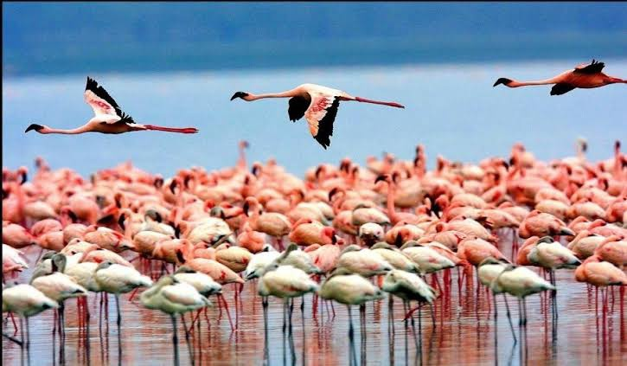

**LAKE MANAYARA NATIONAL PARK**

In only 1 hour and 30 minutes you are able to reach Lake Manyara National Park by road from Arusha and in less than an hour still, if you are coming from the

Ngorongoro crater. a number of areas within the northern part of the park get very busy with large numbers of tourists more so in the afternoon. You are advised to stay within the park or nearby for at least two nights to enjoy it to its fullest.

Lake Manyara National Park well known for the tree climbing lions, the soda ash lake that attracts thousands and pink flamingos, one of Tanzania’s biggest elephant population and breathtaking scenery! This travel guide offers you the most updated information about the attractions, Lake Manyara accommodation, getting there and so much more. Enjoy your safari in Tanzania!

Manyara Region is inhabited by various ethnolinguistic groups and communities. The latter include the **Assa, Gorowa, Kw'adza, Mbugwe, Datooga, Maasai and**

**Barabaig and Irakw**, which is the largest ethnic group in the region

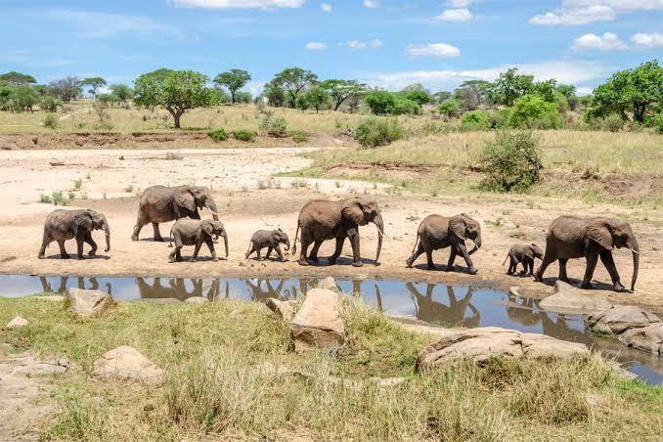

**TARANGIRE NATIONAL PARK**

The Tarangire National Park is known as **a wonderful birding destination and also features large numbers of game, particularly during the dry season, when**

**the Tarangire River is the only source of water in the area**. The landscape is of particular interest too, due to the high number of scenic baobab trees.

By Road. The distance from Arusha to Tarangire National Park is approximately 140 km and takes about **three hours** drive to access the park.

Climate. Tarangire National Park is **warm and dry all year round**, with an average temperature from 75-85 F (24-30 C) during daytime, and 55-65 F (13-18 C) during the night. The area experiences two rainy seasons.

We recommend spending **2-3 days at Tarangire in the dry season**. In Wet season (Nov to May), Wildlife sightings are still decent. You can still find elephants, predators and several species of herbivores, though in fewer numbers than

in dry season.

**NGORONGORO CRATER**

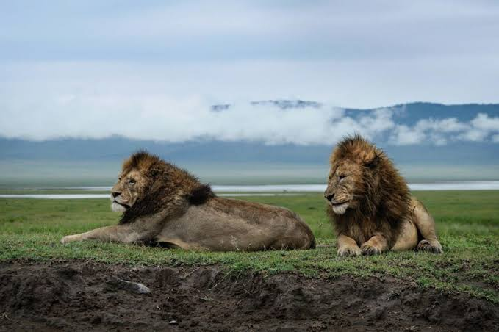

The Ngorongoro Conservation Area is a UNESCO World Heritage Site, and International Biosphere Reserve, covering almost 8.300 sq km with altitudes ranging between 1.020m to 3.577m. Frequently referred to as the eighth wonder of the world, the area encompasses a blend of landscapes, archaeological sites, people

and abundant wildlife that is unsurpassed in Africa. Featuring volcanoes, grasslands, waterfalls and forests, it is home to the nomadic Maasai. The centrepiece, and major landmark, of the Conservation Area is the breath taking Ngorongoro Crater, a natural amphitheatre surrounded by steep walls rising over 600 metres from the crater floor. It is one of the world’s greatest natural spectacles whose magical setting and plentiful wildlife never fail to thrill visitors. The crater is a natural sanctuary for some 30.000 animals including the “big five” of buffalo, elephant, leopard, lion and rhino. It is also home to cheetahs, hartebeests, hippos, hyenas, jackals, reedbucks, serval cats, warhogs, waterbucks, wildebeests, zebras and many bird and insect species

**SERENGETI NATIONAL PARK**

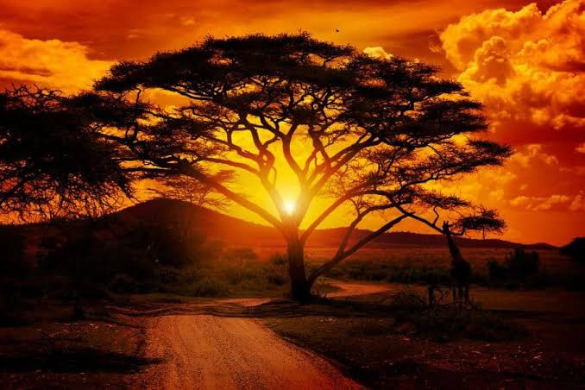

Each year more than six million hooves pound the legendary Serengeti’s endless plains. Triggered by the seasonal rains, more than a million wildebeest, 200.000 zebra and 300.000 Thomson’s gazelle gather to undertake their long trek to new grazing lands. The wildebeest rutting season is a frenzied three week long bout

of territorial conquests and mating, followed by survival of the fittest as the 40km long columns plunge through crocodile infested waters on the annual exodus north. Replenishing the species is the brief population explosion that produces more than 8.000 calves a day before the 1.000 km pilgrimage begins again. Tanzania’s first and most famous park, the Serengeti, is renowned for its wealth of leopard and lion. The vast reaches of the park are a hiding place for the endangered Black Rhino and provide a protected breeding ground for the vulnerable Cheetah, alongside the Serengeti’s thousands of other diverse species, from the 500 varieties of bird to 100 different types of dung beetle. After the rains, the Serengeti’s magical golden horizon is transformed into an endless green carpet, flecked with wildflowers. The

famous plains are interspersed with wooded hills, towering termite mounds, monumental rocky kopjes, and rivers lined with elegant acacia trees.

To search for the at-times exlusive wildebeest migration, visit the Serengeti from December to July. To see predators, June to October is the best months. For the best chance of finding the migration, allow a minimum of three days, longer if possible.

**THE EASTERN SAFARI CIRCUIT**

**SAADANI NATIONAL PARK**

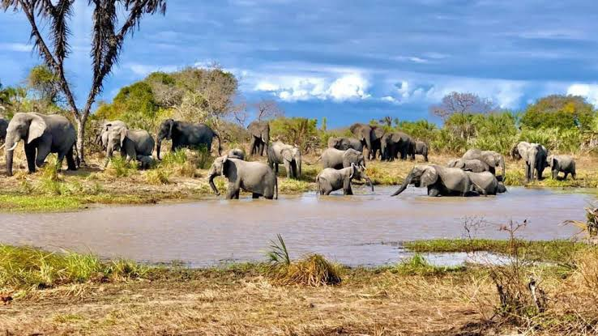

The Saadani National Park is the perfect union of beach and bush. Located just 70 km north of Bagamoyo and immediately accessible by paved road from Dar es Salaam, Saadani has recently become a fully protected national park and is a popular day-trip from beach resorts scattered along Tanzania's northern coast.

The Wami River, which passes through Saadani National Park and empties into

the Indian Ocean, hosts a large population of hippos, crocodiles, flamingos, and many other large bird species. Elephants have been rumoured to be seen bathing and playing on Saadani's beach, especially in the early hours of the morning. A good choice for visitors in Dar es Salaam or Zanzibar who don't have time for longer safaris to visit more remote parks around the country, Saadani is easily visited for a day trip or over a weekend.

**THE CENTER SAFARI CIRCUIIT**

**RUAHA NATIONAL PARK**

Ruaha National Park is located on the

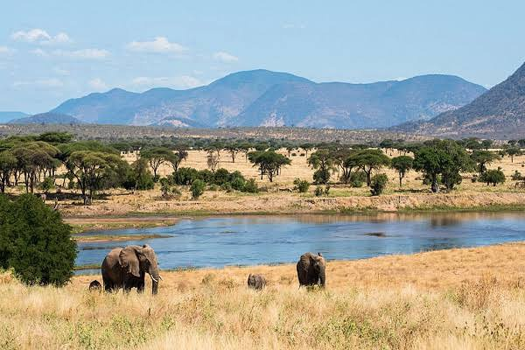

center of Tanzania about 100 km west of the town of Iringa. It is the second-largest in the country, after the Serengeti with a surface area of 10 300 square kilometers. It takes its name from the Ruaha River that runs through it, which is one of the only permanent water sources in the dry season and therefore attracts a very high concentration of wildlife. The area has been protected since 1951.

The park is famous for its elephant herds, the largest in East Africa. Between 10,000

and 12,000 elephants congregate in the Ruaha Valley during the dry season. A wide variety of antelopes can also be found in the park, including black hippotragus, defassa cob, impala and greater kudu. Among carnivores, hyenas, leopards and cheetahs are relatively common, while small populations of lions, wild dogs and jackals remain. Many crocodiles and hippos live along the river. The remaining water falls along the Great Ruaha River are also important habitat for hippopotamus, fish and crocodiles.

Finally, the park is particularly popular with birders. More than 1,450 species of birds have been identified here.

**SOUTHERN SAFARI CIRCUIT**

**SELOUS GAME RESERVE**

**Se**lous Game reserve is located

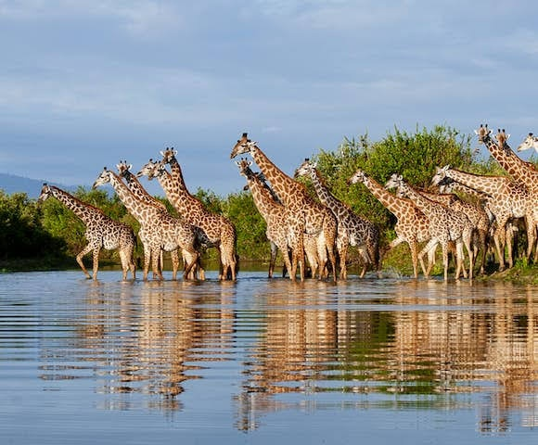

in the south of the country, about 219 kilometers from the busy city of Dar Es Salaam and may take about 4 hours drive. It is also a UNESCO World Heritage Site. It's the largest protected game reserve on the African continent covering an area of 54,600 square kilometers. The park includes rivers, swamps, forests, grasslands, etc. The area is also highly protected from human activity and tourism is regulated to avoid large tourist numbers. The management of the park is also a good example of ecotourism.

Selous Game Reserve is crossed by River Rufiji. The reserve is separated into 2 major sections by the river which are the northern and southern Selous.

The northern part is about 5% of the total area of the reserve and hunting is completely prohibited in this area which has been exclusively set aside for photographic safaris. The best time to visit Selous Game Reserve is from June to October.

The southern part is separated into various hunting blocks each covering an area of approximately 1,000 square kilometers.

In Selous Game reserve you can find approximately 145,000 buffalos, 4,000 Lions, 100,000 wildebeests, large hands of giraffes, 35000 zebras, 40000 hippos, 250,000 impalas, large numbers of Lichtenstein’s hartebeests, waterbucks, elands and bushbucks, in addition to leopards, crocodiles and hyenas. Around 445 different birds species have been recorded to live in the various habitats in the reserve.

CONTACTS

E-mail mysteriousislandstours@gmail.com

Phone: 0777 386565

0715 737336